List of Experiments
Set 1: Monthly Sales Data
- Create a line chart to visualize the monthly sales. Label the axes and title the chart appropriately.

Code :

# Load required library
install.packages('ggplot2')
library(ggplot2)

# Create dataset
sales_data <- data.frame(
Month = factor(c('January', 'February', 'March', 'April', 'May'),
levels = c('January', 'February', 'March', 'April', 'May')),
Sales = c(15000, 18000, 22000, 20000, 23000)
)

# Generate Line Chart
ggplot(sales_data, aes(x = Month, y = Sales, group = 1)) +
geom_line(color = "black", linewidth = 1) +
geom_point(color = "black", size = 3) +
labs(title = "Monthly Sales Trend", x = "Month", y = "Sales (in $)") +
theme_minimal(base_family = "Times") +
theme(
plot.title = element_text(face = "bold", size = 14, hjust = 0.5),
axis.title = element_text(size = 12),
panel.grid.major = element_line(color = "lightgray", linetype = "dashed")
)

Output:
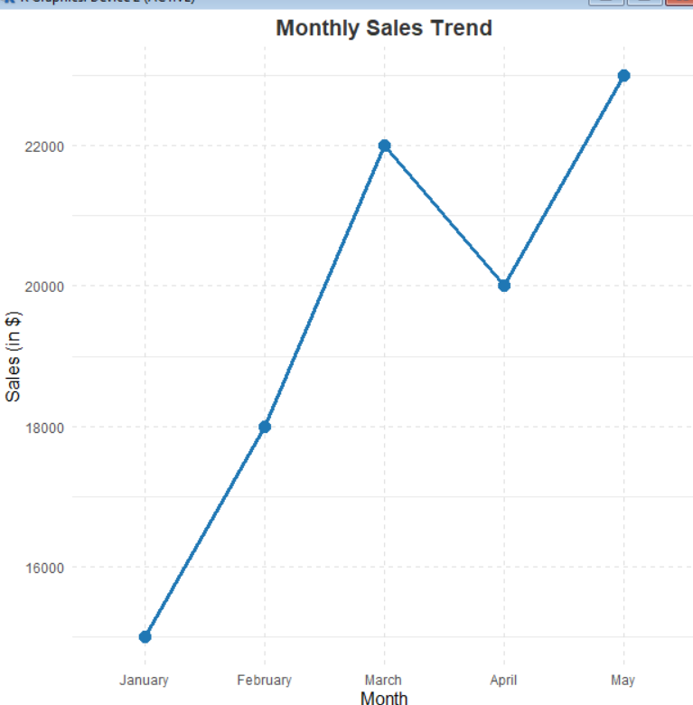

- Generate a bar chart to display the top-selling products for the year. Label the chart elements.

Code:
library(ggplot2)

product_data <- data.frame(
Product = c('Product A', 'Product B', 'Product C', 'Product D', 'Product E'),
Annual_Sales = c(45000, 38000, 29000, 18000, 12000)
)

palette_colors <- c('#1f77b4', '#aec7e8', '#ff7f0e', '#ffbb78', '#2ca02c')

ggplot(product_data, aes(x = reorder(Product, -Annual_Sales), y = Annual_Sales, fill = Product)) +
geom_bar(stat = "identity", width = 0.6, color = "white", show.legend = FALSE) +
scale_fill_manual(values = palette_colors) +
labs(title = "Top-Selling Products for the Year", x = "Products", y = "Annual Sales (in $)") +
theme_minimal(base_family = "Times") +
theme(
plot.title = element_text(face = "bold", size = 14, hjust = 0.5, color = "#333333"),
axis.title = element_text(size = 12),
panel.grid.major.y = element_line(color = "#e0e0e0", linetype = "dashed")
)

Output:
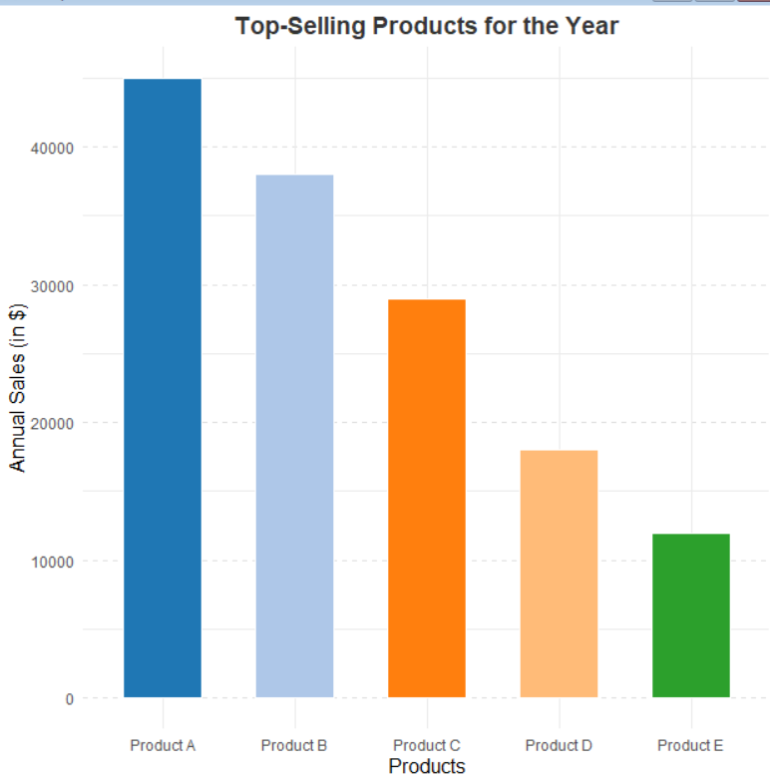
- Develop a scatter plot to explore the relationship between advertising budget and monthly sales.
Explain the insights drawn from the scatter plot.

Code:
library(ggplot2)

relationship_data <- data.frame(
Month = c('January', 'February', 'March', 'April', 'May'),
Budget = c(1000, 1200, 1800, 1500, 2000),
Sales = c(15000, 18000, 22000, 20000, 23000)
)

ggplot(relationship_data, aes(x = Budget, y = Sales)) +
geom_point(size = 4, color = "#ff7f0e") +
geom_text(aes(label = Month), vjust = -1, family = "Times", fontface = "bold", color = "#333333") +
labs(title = "Advertising Budget vs. Monthly Sales", x = "Advertising Budget ($)", y = "Monthly Sales ($)") +
xlim(900, 2100) + ylim(14000, 24000) +
theme_minimal(base_family = "Times") +
theme(
plot.title = element_text(face = "bold", size = 14, hjust = 0.5, color = "#333333"),
axis.title = element_text(size = 12),
panel.grid.major = element_line(color = "#e0e0e0", linetype = "dashed")
)
Output:
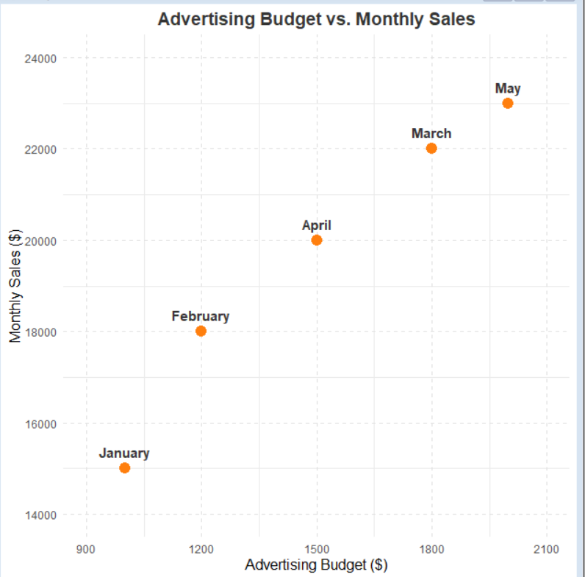

4. Build an interactive dashboard combining the line chart and bar chart to allow users to explore
sales data interactively.

Code:
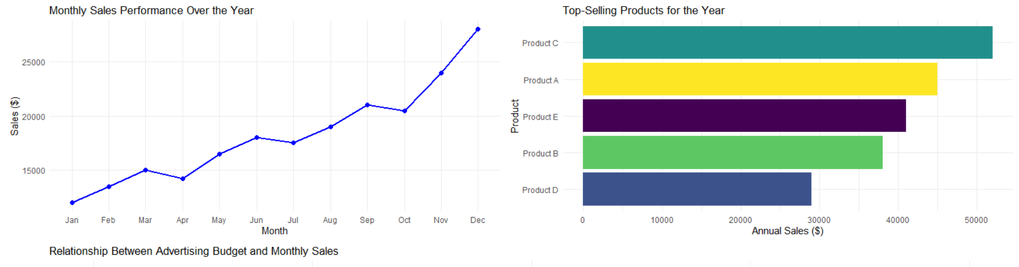

Set 2 : Customer Feedback Analysis

1. Create a histogram to represent the distribution of customer ages. Label the axes and title the
chart.

Code:
library(ggplot2)

# Create dataset
customer_data <- data.frame(
Age = c(25, 30, 35, 28, 40)
)

# Plot Histogram
ggplot(customer_data, aes(x = Age)) +
geom_histogram(breaks = seq(20, 45, by = 5), fill = "skyblue", color = "black", closed = "left") +
labs(title = "Distribution of Customer Ages", x = "Age", y = "Number of Customers") +
theme_minimal()

Output:
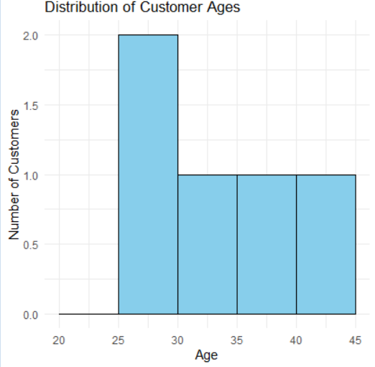

2. Generate a pie chart to display the overall distribution of customer satisfaction scores. Include
labels.

Code:
library(ggplot2)
library(dplyr)

# Create dataset
customer_data <- data.frame(
Satisfaction_Score = c(4, 5, 3, 4, 5)
)

# Aggregate and format data for the pie chart
pie_data <- customer_data %>%
group_by(Satisfaction_Score) %>%
summarise(Count = n()) %>%
mutate(Fraction = Count / sum(Count),
Label = paste0("Score ", Satisfaction_Score, "\n", round(Fraction * 100, 1), "%"))

# Plot Pie Chart
ggplot(pie_data, aes(x = "", y = Fraction, fill = as.factor(Satisfaction_Score))) +
geom_bar(stat = "identity", width = 1) +
coord_polar(theta = "y") +
labs(title = "Overall Distribution of Customer Satisfaction Scores", fill = "Score") +
geom_text(aes(label = Label), position = position_stack(vjust = 0.5)) +
theme_void()

Output:
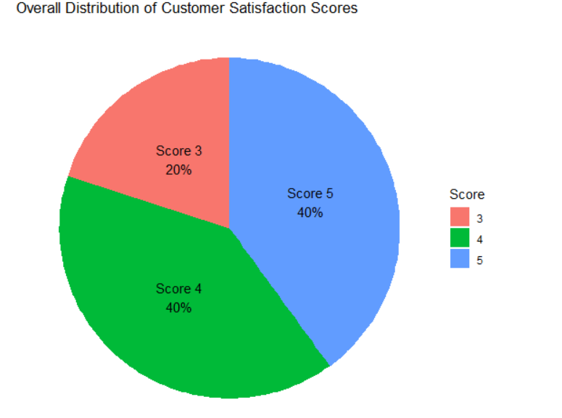

3. Build a stacked bar chart to visualize the distribution of customer satisfaction scores by age
group.

Code:
library(ggplot2)
library(dplyr)

# Create dataset
customer_data <- data.frame(
Age = c(25, 30, 35, 28, 40),
Satisfaction_Score = c(4, 5, 3, 4, 5)
)

# Categorize ages into brackets
bar_data <- customer_data %>%
mutate(Age_Group = case_when(
Age < 30 ~ "20-29",
Age >= 30 & Age < 40 ~ "30-39",
TRUE ~ "40-49"
))

# Plot Stacked Bar Chart
ggplot(bar_data, aes(x = Age_Group, fill = as.factor(Satisfaction_Score))) +
geom_bar(position = "stack") +
labs(title = "Satisfaction Scores by Age Group", x = "Age Group", y = "Number of Customers", fill = "Satisfaction Score") +
theme_minimal()

Output:
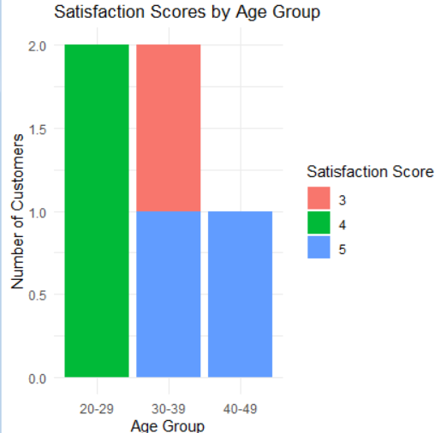

4. Develop a word cloud from open-ended customer feedback to identify prevalent customer
sentiments.

Code:
library(wordcloud)
library(tm)

# Open-ended feedback text array
feedback_text <- c(
"Great service and friendly staff! Very happy with my purchase.",
"Excellent customer support, fast delivery, highly recommend.",
"The product quality is average, but the service was okay.",
"Good experience overall, easy to use and very helpful.",
"Amazing product! Exceeded my expectations, absolutely perfect."
)

# Text cleaning process
corpus <- Corpus(VectorSource(feedback_text)) %>%
tm_map(content_transformer(tolower)) %>%
tm_map(removePunctuation) %>%
tm_map(removeNumbers) %>%
tm_map(removeWords, stopwords("english"))

# Plot Word Cloud
wordcloud(words = corpus, min.freq = 1, max.words = 50,
random.order = FALSE, colors = brewer.pal(8, "Dark2"))

Output:


Set 3: Employee Performance Evaluation

1. Create a line chart to visualize the performance trend of employees over time. Include a legend
and labels.
Code:
library(ggplot2)

# Dataset
employee_data <- data.frame(
Years_of_Service = c(5, 3, 7, 4, 2),
Performance_Score = c(85, 92, 78, 90, 76)
)

# Order by service time to get a progressive line plot
employee_data <- employee_data[order(employee_data$Years_of_Service), ]

ggplot(employee_data, aes(x = Years_of_Service, y = Performance_Score)) +
geom_line(aes(color = "Employee Performance"), size = 1) +
geom_point(color = "purple", size = 2.5) +
scale_color_manual(values = c("Employee Performance" = "purple")) +
labs(title = "Performance Score Trend over Years of Service",
x = "Years of Service", y = "Performance Score", color = "Legend") +
theme_minimal()

Output:
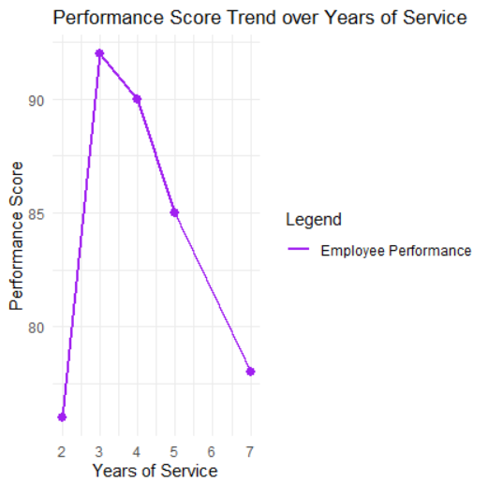

2. Generate a bar chart showing the distribution of employees across different departments. Label
the chart elements.

Code:
library(ggplot2)

employee_data <- data.frame(
Department = c("Sales", "HR", "Marketing", "Sales", "HR")
)

ggplot(employee_data, aes(x = Department, fill = Department)) +
geom_bar(color = "black", alpha = 0.7) +
scale_y_continuous(breaks = c(0, 1, 2)) +
labs(title = "Distribution of Employees Across Departments",
x = "Department", y = "Number of Employees") +
theme_minimal() +
theme(legend.position = "none")

Output:
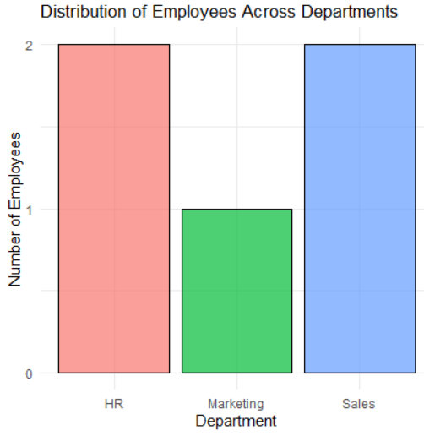

3. Build a scatter plot to explore the relationship between product price and quantity available.
Explain the findings.

Code:
library(ggplot2)

employee_data <- data.frame(
Years_of_Service = c(5, 3, 7, 4, 2),
Performance_Score = c(85, 92, 78, 90, 76)
)

ggplot(employee_data, aes(x = Years_of_Service, y = Performance_Score)) +
geom_point(color = "darkorange", size = 4, shape = 18) +
labs(title = "Correlation: Years of Service vs Performance Score",
x = "Years of Service", y = "Performance Score") +
theme_minimal()
Output:
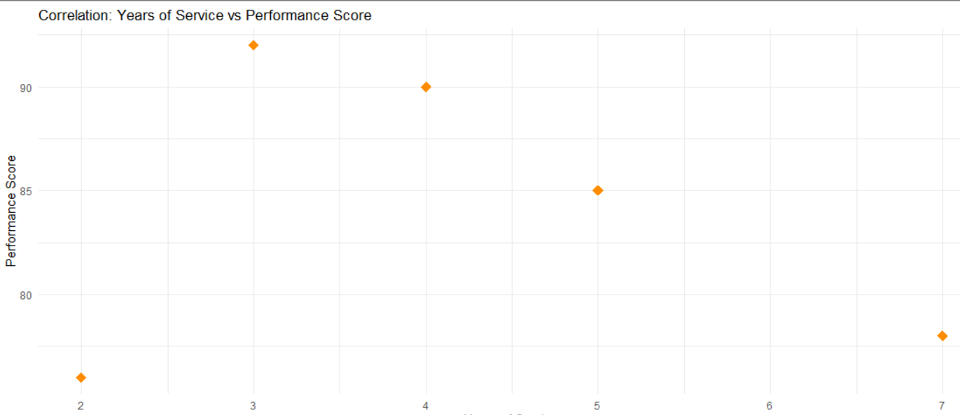

Set 4:

1. Create a bar chart to visualize the quantity of each product in the inventory. Label the axes and
title the chart.
Code:
# Load required libraries
library(ggplot2)
library(dplyr)

# Create the product inventory dataset
inventory_data <- data.frame(
Product_ID = 1:5,
Product_Name = c("Product A", "Product B", "Product C", "Product D", "Product E"),
Category = c("Electronics", "Apparel", "Electronics", "Home & Kitchen", "Apparel"),
Price = c(150.00, 45.00, 299.99, 85.50, 35.00),
Quantity_Available = c(250, 175, 300, 200, 220)
)

# View the dataset
print(inventory_data)

# 1. Bar Chart: Product Name vs Quantity Available
ggplot(inventory_data, aes(x = reorder(Product_Name, -Quantity_Available), y = Quantity_Available, fill = Product_Name)) +
geom_col(width = 0.6, show.legend = FALSE) +
geom_text(aes(label = Quantity_Available), vjust = -0.5, fontface = "bold", size = 4) +
scale_fill_brewer(palette = "Blues") +
labs(
title = "Inventory Quantity by Product",
subtitle = "Total stock units available per product",
x = "Product Name",
y = "Quantity Available (Units)"
) +
theme_minimal(base_size = 12) +
theme(
plot.title = element_text(face = "bold", size = 14),
panel.grid.major.x = element_blank()
)
Output:
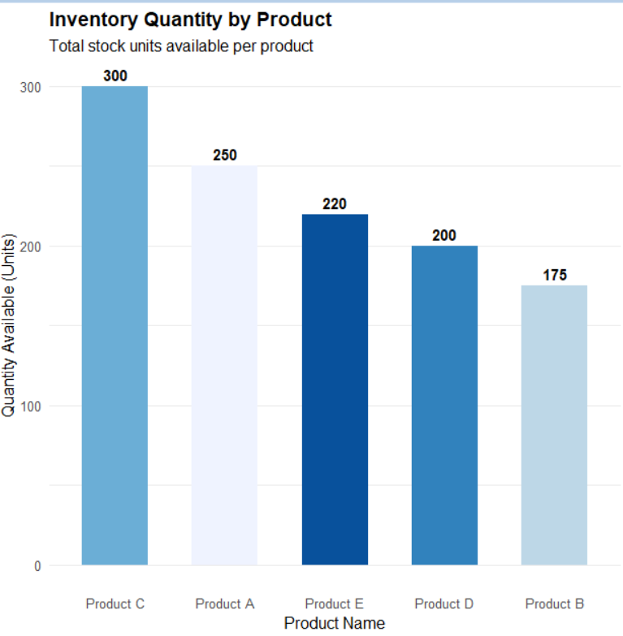

2. Generate a stacked bar chart to show the quantity of each product within different product
categories.
Code:
# Load required libraries
library(ggplot2)
library(dplyr)

# Create the product inventory dataset
inventory_data <- data.frame(
Product_ID = 1:5,
Product_Name = c("Product A", "Product B", "Product C", "Product D", "Product E"),
Category = c("Electronics", "Apparel", "Electronics", "Home & Kitchen", "Apparel"),
Price = c(150.00, 45.00, 299.99, 85.50, 35.00),
Quantity_Available = c(250, 175, 300, 200, 220)
)

# View the dataset
print(inventory_data)

# 2. Stacked Bar Chart: Category vs Quantity Available by Product
ggplot(inventory_data, aes(x = Category, y = Quantity_Available, fill = Product_Name)) +
geom_col(position = "stack", width = 0.5, color = "white") +
geom_text(
aes(label = paste0(Product_Name, "\n(", Quantity_Available, ")")),
position = position_stack(vjust = 0.5),
color = "white",
size = 3.5,
fontface = "bold"
) +
scale_fill_viridis_d(option = "plasma") +
labs(
title = "Product Quantity Distribution Across Categories",
subtitle = "Stacked view of individual product contributions to category inventory",
x = "Product Category",
y = "Total Quantity Available",
fill = "Product Name"
) +
theme_minimal(base_size = 12) +
theme(plot.title = element_text(face = "bold", size = 14))

Output:
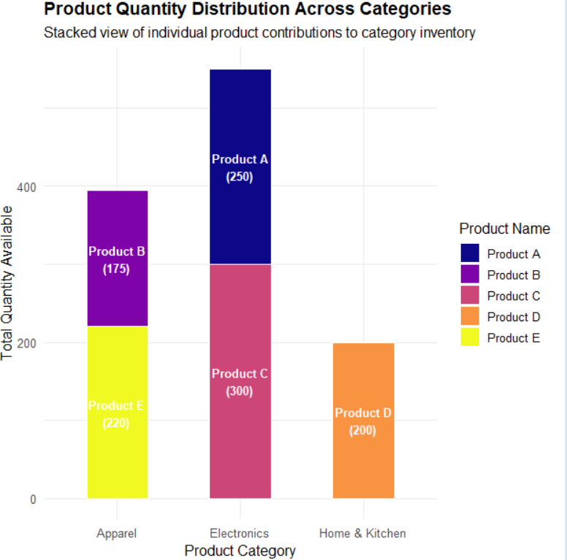3. Build a scatter plot to explore the relationship between product price and quantity available.
Explain the findings.
Code:
# ============================================================
# Task 3: Complete Self-Contained Script (Dataset + Scatter Plot)
# ============================================================

# 1. Load required libraries
library(ggplot2)
library(dplyr)

# 2. Create the dataset
inventory_data <- data.frame(
Product_ID = 1:5,
Product_Name = c("Product A", "Product B", "Product C", "Product D", "Product E"),
Category = c("Electronics", "Apparel", "Electronics", "Home & Kitchen", "Apparel"),
Price = c(150.00, 45.00, 299.99, 85.50, 35.00),
Quantity_Available = c(250, 175, 300, 200, 220)
)

# 3. Generate the Scatter Plot
ggplot(inventory_data, aes(x = Price, y = Quantity_Available, label = Product_Name)) +
geom_point(aes(color = Category), size = 5, alpha = 0.8) +
geom_text(vjust = -1, fontface = "bold", size = 3.8) +
geom_smooth(method = "lm", se = FALSE, color = "darkgray", linetype = "dashed") +
labs(
title = "Relationship Between Product Price and Quantity Available",
subtitle = "Exploring stock allocation relative to unit price",
x = "Unit Price ($)",
y = "Quantity Available (Units)",
color = "Category"
) +
theme_minimal(base_size = 12) +
theme(
plot.title = element_text(face = "bold", size = 14)
)
Output:
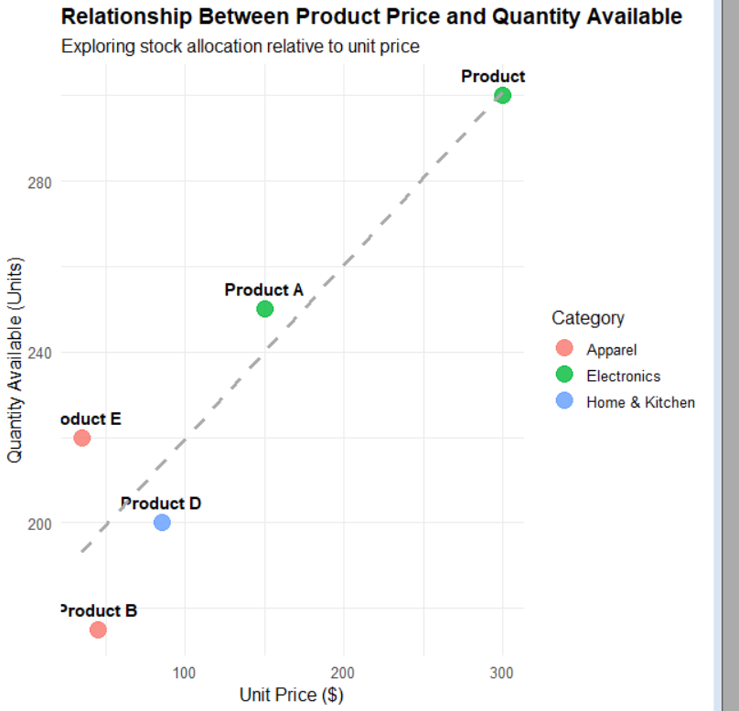

Set 5:

1. Create a line chart to visualize the trend in daily page views over time. Label the axes and title the
chart.
Code:
# Load required libraries
library(ggplot2)
library(dplyr)
library(tidyr)

# Create the website traffic dataset
traffic_data <- data.frame(
Date = as.Date(c("2023-01-01", "2023-01-02", "2023-01-03", "2023-01-04", "2023-01-05")),
Page_Views = c(1500, 1600, 1400, 1650, 1800),
CTR = c(2.3, 2.7, 2.0, 2.4, 2.6),
# Added user interaction metrics for Task 3
Likes = c(120, 145, 95, 130, 160),
Shares = c(45, 55, 30, 50, 65),
Comments = c(25, 32, 15, 22, 35)
)

# Preview the data
print(traffic_data)

# 1. Line Chart: Daily Page Views Trend
ggplot(traffic_data, aes(x = Date, y = Page_Views)) +
geom_line(color = "#1F77B4", size = 1.2) +
geom_point(color = "#1F77B4", size = 3) +
geom_text(aes(label = Page_Views), vjust = -0.8, fontface = "bold", size = 3.5) +
scale_x_date(date_labels = "%b %d, %Y", date_breaks = "1 day") +
scale_y_continuous(limits = c(1200, 2000)) +
labs(
title = "Daily Page Views Trend",
subtitle = "Website traffic trajectory from Jan 01 to Jan 05, 2023",
x = "Date",
y = "Page Views"
) +
theme_minimal(base_size = 12) +
theme(plot.title = element_text(face = "bold", size = 14))
Output:
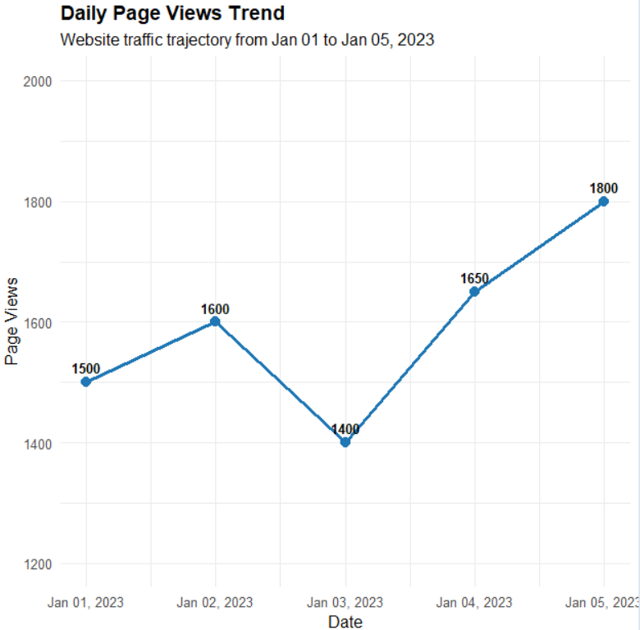
2. Generate a stacked area chart to represent the overall sales trend for all products over the three
months.
Code:
# Load required libraries
library(ggplot2)
library(dplyr)
library(tidyr)

# Create the website traffic dataset
traffic_data <- data.frame(
Date = as.Date(c("2023-01-01", "2023-01-02", "2023-01-03", "2023-01-04", "2023-01-05")),
Page_Views = c(1500, 1600, 1400, 1650, 1800),
CTR = c(2.3, 2.7, 2.0, 2.4, 2.6),
# Added user interaction metrics for Task 3
Likes = c(120, 145, 95, 130, 160),
Shares = c(45, 55, 30, 50, 65),
Comments = c(25, 32, 15, 22, 35)
)

# Preview the data
print(traffic_data)

# 2. Bar Chart: Top N Days with Highest CTR
top_n_days <- 3 # Change N as needed

top_ctr_data <- traffic_data %>%
slice_max(order_by = CTR, n = top_n_days)

ggplot(top_ctr_data, aes(x = reorder(format(Date, "%b %d"), CTR), y = CTR)) +
geom_col(fill = "#2CA02C", width = 0.5) +
geom_text(aes(label = paste0(CTR, "%")), hjust = -0.2, fontface = "bold", size = 4) +
coord_flip() +
scale_y_continuous(limits = c(0, 3.2), labels = function(x) paste0(x, "%")) +
labs(
title = paste("Top", top_n_days, "Days by Click-Through Rate (CTR)"),
subtitle = "Dates with the highest user click engagement",
x = "Date",
y = "Click-Through Rate (%)"
) +
theme_minimal(base_size = 12) +
theme(
plot.title = element_text(face = "bold", size = 14),
panel.grid.major.y = element_blank()
)
Output:
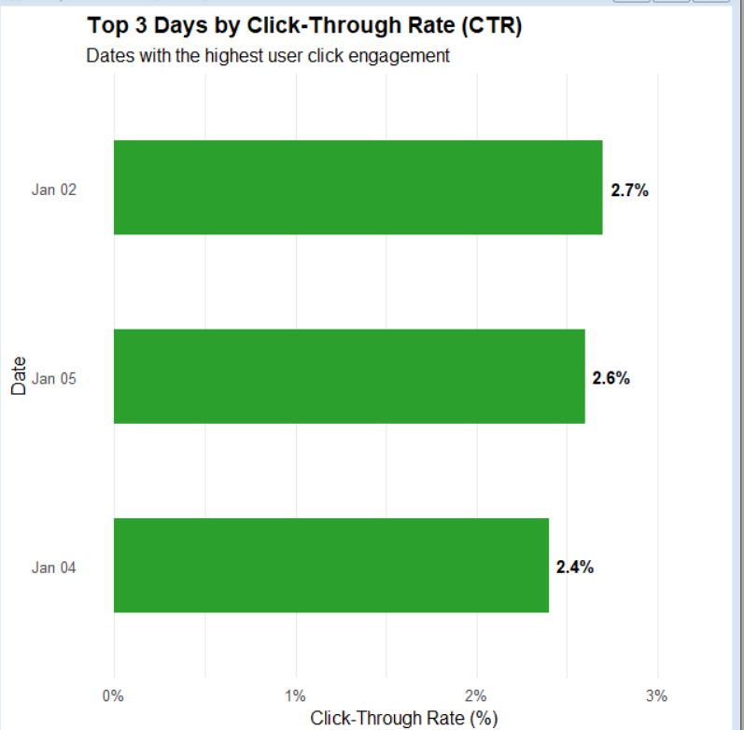

3. Build a table to show the monthly sales data for each product. Label the table elements.
Code:
# Load required libraries
library(ggplot2)
library(dplyr)
library(tidyr)

# Create the website traffic dataset
traffic_data <- data.frame(
Date = as.Date(c("2023-01-01", "2023-01-02", "2023-01-03", "2023-01-04", "2023-01-05")),
Page_Views = c(1500, 1600, 1400, 1650, 1800),
CTR = c(2.3, 2.7, 2.0, 2.4, 2.6),
# Added user interaction metrics for Task 3
Likes = c(120, 145, 95, 130, 160),
Shares = c(45, 55, 30, 50, 65),
Comments = c(25, 32, 15, 22, 35)
)

# Preview the data
print(traffic_data)

# 3. Stacked Area Chart: Distribution of User Interactions
# Convert data from wide to long format for stacked plotting
interactions_long <- traffic_data %>%
pivot_longer(
cols = c(Likes, Shares, Comments),
names_to = "Interaction_Type",
values_to = "Count"
)

ggplot(interactions_long, aes(x = Date, y = Count, fill = Interaction_Type)) +
geom_area(alpha = 0.85, color = "white", size = 0.3) +
scale_fill_brewer(palette = "Set2") +
scale_x_date(date_labels = "%b %d, %Y", date_breaks = "1 day") +
labs(
title = "Distribution of Website User Interactions Over Time",
subtitle = "Daily volume composition of Likes, Shares, and Comments",
x = "Date",
y = "Total Interaction Count",
fill = "Interaction Type"
) +
theme_minimal(base_size = 12) +
theme(plot.title = element_text(face = "bold", size = 14))
Output:
